**Create a Food Web**

**Name:______________________________ Date:** _________________

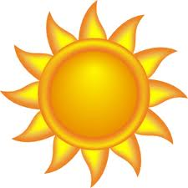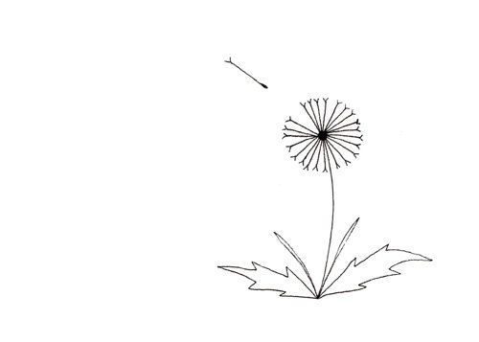Explore your outdoor classroom, and then create a Food Web that includes plant(s) and animal(s) that you found (or could find) in your outdoor classroom. Use the Example Food Web Components chart (on page 3) and the diet information on the Alabama Wildlife Federation’s Dig into Plants and Wonders of Wildlife webpages to help you complete your Food Web.

1. Draw a picture of each plant and animal in your Food Web in each circle.

2. Identify the plant or animal species inside each circle by name.

1. Draw arrows **from** the plant or animal that is eaten **to** the animal(s) that might eat it to show the flow of energy from the sun through the producer(s), consumer(s), and apex predator(s) to the decomposer(s).

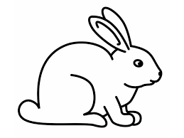

**dandelion**

**rabbit**

**________________**

**________________**

**________________**

**________________**

**________________**

**________________**



*Alabama Wildlife Federation Outdoor Classroom Field Investigation Activity Sheet: Create a Food Web, v1, page 1 of 3*

Use the diagram of **your Food Web** (on page 1) to answer the following questions.

4. List the producer(s) in your food web:_________________________________________________________

5. List the consumer(s) in your food web:_________________________________________________________

_______________________________________________________________________________________

6. List the apex predator(s) in your food web:_____________________________________________________

7. List the decomposer(s) in your food web:_______________________________________________________

8. What would happen if all of the plants in the outdoor classroom disappeared? ___________________________

_______________________________________________________________________________________

9. What would happen if all of the apex predators in the outdoor classroom disappeared?_____________________

_______________________________________________________________________________________

10. What role do decomposers play in an ecosystem’s food web? _______________________________________

_______________________________________________________________________________________

11. Where does ALL of the energy that moves through the food webs in ALL ecosystems originate?_____________

12. What does your food web diagram for your outdoor classroom (on page 1) represent?_____________________

_______________________________________________________________________________________

_______________________________________________________________________________________



*Alabama Wildlife Federation Outdoor Classroom Field Investigation Activity Sheet: Create a Food Web, v1, page 2 of 3*

|  |  |  |  |  |
| --- | --- | --- | --- | --- |
| **EXAMPLE FOOD WEB COMPONENTS**  (A component is one part or element of the larger whole.) | | | | |
| **Plants**  (Producers) | **Herbivores**  (Primary Consumers) | **Omnivores**  (Secondary/Tertiary Consumers) | **Carnivores**  (Secondary/Tertiary Consumers) | **Detritivores & Fungus**  (Decomposers) |
| Grasses | Armyworms | Ants | Spiders | Mushrooms |
| Wildflowers | Caterpillars | Wasps | Fleas | Worms |
| Herbs | Butterflies | Lady Bugs | Ticks | Spiders |
| Shrubs | Bees | Crickets | Bats | Ants |
| Trees | Moths | Mosquitos | Snakes | Flies |
| Nuts | Grasshoppers | Songbirds | *Alligators | Beetles |
| Berries | Treehoppers | Squirrels & Chipmunks | *Some Fish | Millipedes |
| Acorns | Leafhoppers | Opossums | *Owls | Pill Bugs/Roly Polies |
| Pinecones | Katydids | Racoons | *Bobcats | Cockroaches |
| Seeds | Deer | Skunks | *Hawks | Snails |
| Fruits | Beavers | Frogs & Toads |  | Slugs |
| Aquatic plants | Rabbits | Salamanders |  |  |
| Algae | Some Fish | Turtles |  |  |
|  |  | Lizards |  |  |
|  |  | *Foxes (Red and Gray) |  |  |
|  |  | *Coyotes |  |  |
|  | *Alabama Wildlife Federation Outdoor Classroom Field Investigation Answer Sheet: Create a Food Web, v1, page 3 of 3* | *Black Bears |  | *\*Apex Predators* |