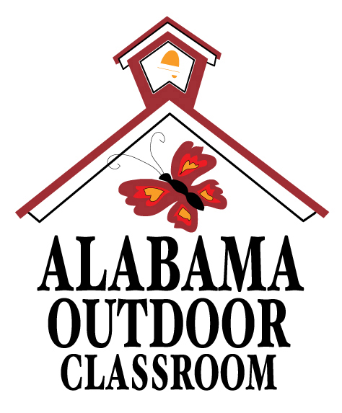
Comparing Adult to offspring: Black Swallowtail
Answer Sheet

Explore your outdoor classroom and look for a Black Swallowtail adult and baby.
Compare & Contrast them below.
*If you cannot find both, complete observations on the one you find and research the other when you return to the classroom using the Alabama Wildlife Federation’s Wonders of Wildlife Black Swallowtail webpage.
 | ADULT |  | OFFSPRING
 | 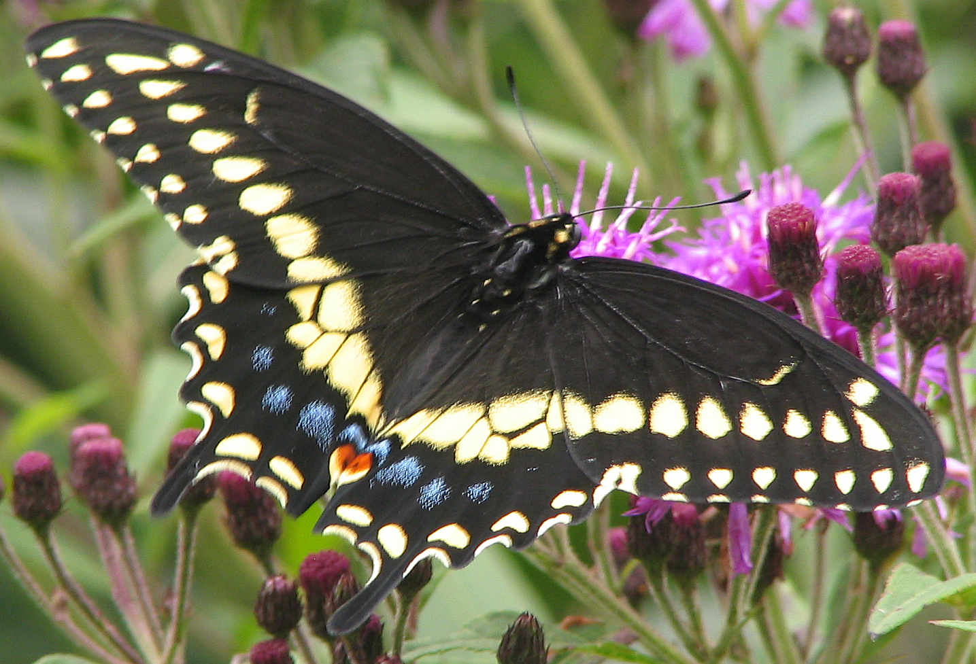  Draw a picture of the adult. |  | 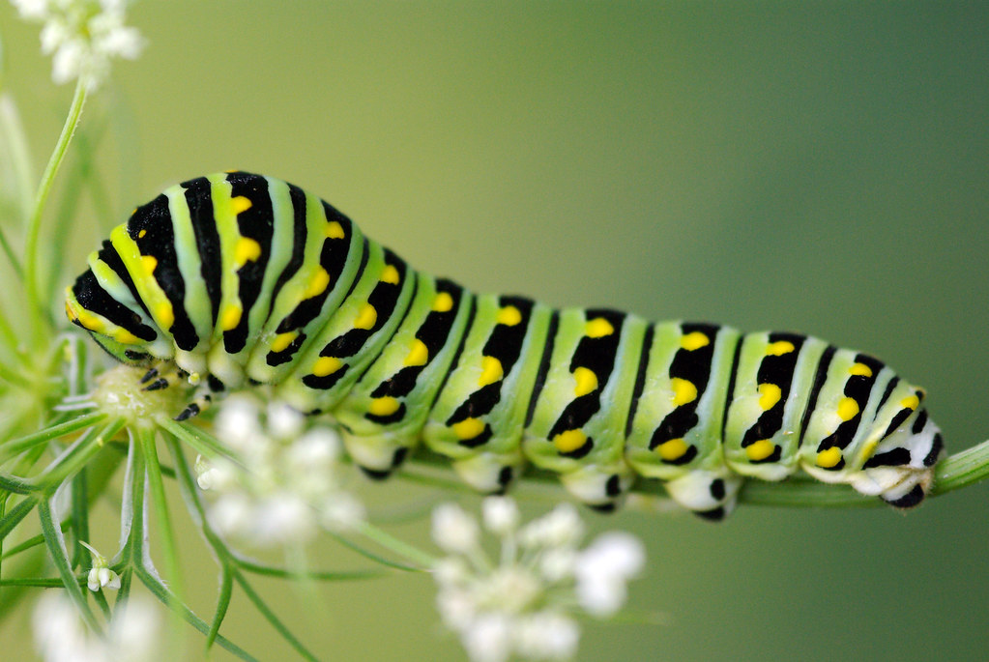  Draw a picture of the offspring.
 | Does the adult look like its offspring?  No |  | Does the offspring look like the adult?  No
 | What color or colors is it?  Black with two rows of yellow spots, often with blue between the rows. |  | What color or colors is it?  Dark with a white “saddle” through midsection or bright green with black dashes and yellow dots.

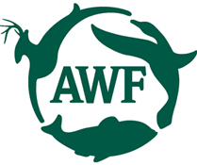
Alabama Wildlife Federation Outdoor Classroom Field Investigation Answer Sheet: Comparing Adult to Offspring v3, page 1 of 2

 | ADULT |  | OFFSPRING
 | What type of skin or covering does it have?  Wings covered in scales and hairs. Body has an exoskeleton covered in small hairs. |  | What type of skin or covering does it have?  Exoskeleton that is soft and squishy to the touch.
 | Does it have wings?  Yes |  | Does it have wings?  No
 | How many legs does it have?  6 |  | How many legs does it have?  6
 | What is the adult called?  Butterfly |  | What is the baby called?  Caterpillar
 | How do you know they are related?  Butterflies start as caterpillars before they emerge from their cocoons. |  | How do you know they are related?  Caterpillars turn into butterflies after they emerge from their cocoons.
Alabama Wildlife Federation Outdoor Classroom Field Investigation Answer Sheet: Comparing Adult to Offspring v3, page 2 of 2

