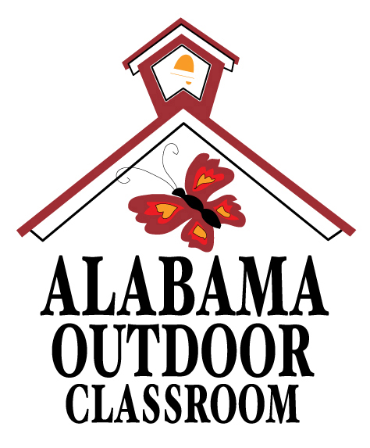
Birds, Trees and Basic Needs
Name: | __________________________________________________________________  -------------------------------------------------------------------  __________________________________________________________________

Draw a picture of a bird, a tree, and a picture of yourself.
Circle the food, water, air, sun and shelter that you can find in your outdoor classroom for birds, trees and you.

Living Things | Food | Water | Air | Sun | Shelter
1. Draw a Bird | 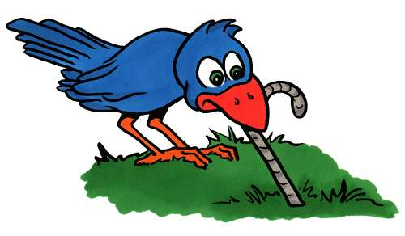  bugs & seeds | 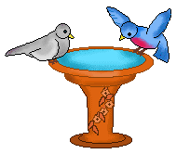  bird bath |   all around us | 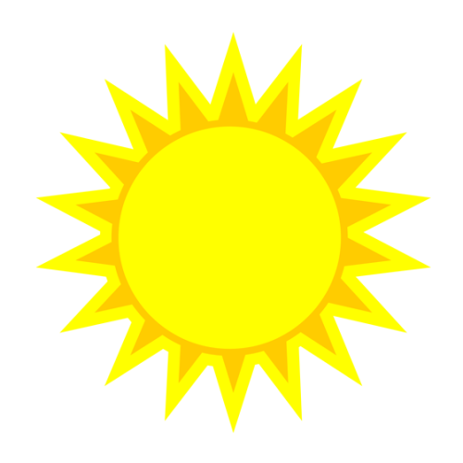  sunlight | 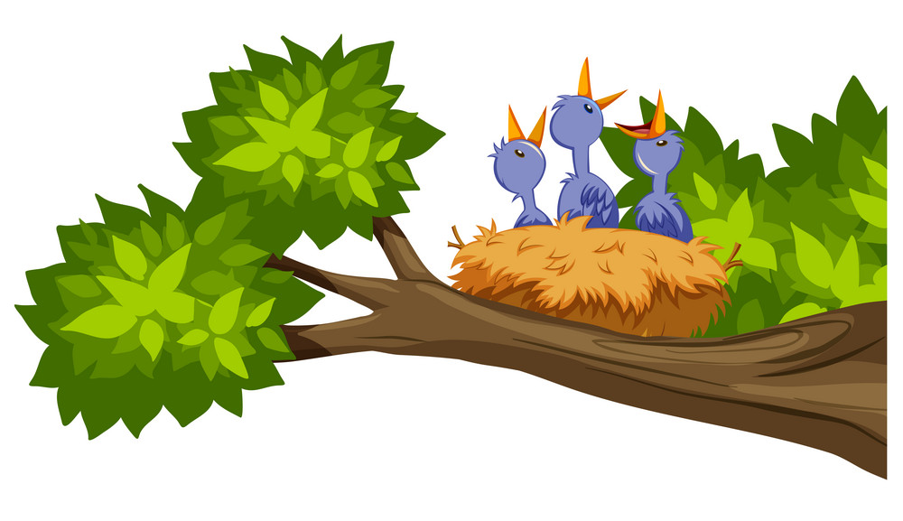  bushes & trees
2. Draw a Tree | 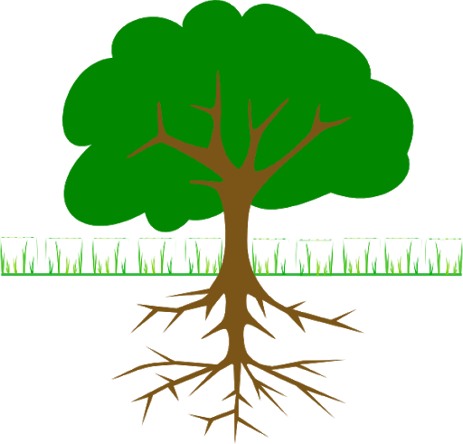  food in soil | rain  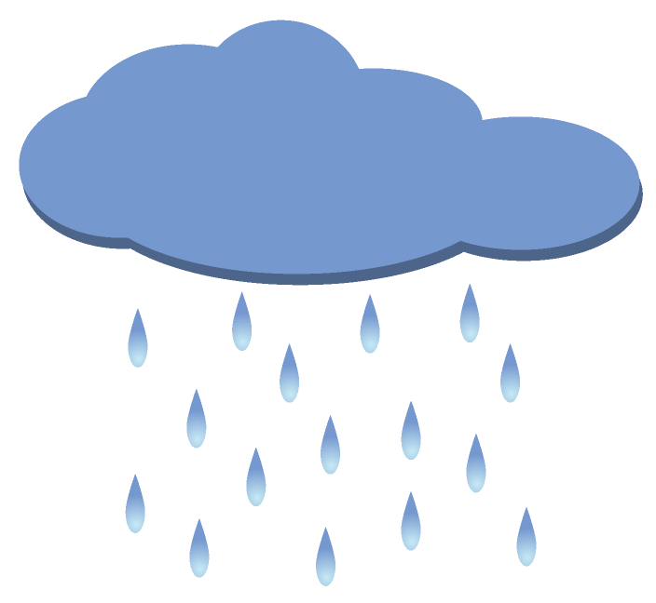 | all around us | sunlight | space to grow  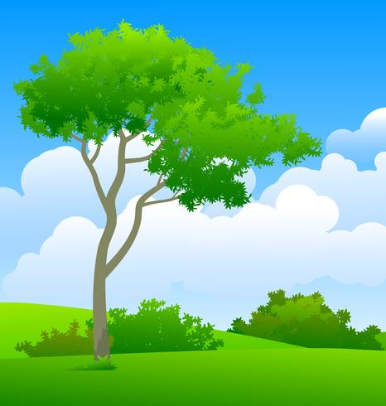
3. Draw You | meat & vegetables  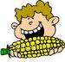 | 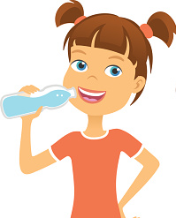  clean water | all around us | sunlight | 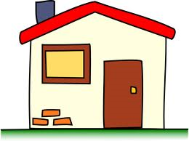  home

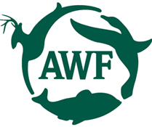
Alabama Wildlife Federation Outdoor Classroom Field Investigation Activity Page: Birds, Trees & Basic Needs, page 1 of 1

