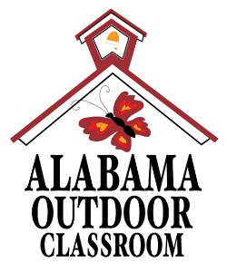
Alabama Outdoor Classroom BioBlitz Observation Sheet
Student/Group Name(s):____________________________________________________
Teacher’s Name:_________________________________ Grade:___________________
School Address:________________________________________
Location on Campus:______________________________________________________________________
Date of Observation:______________________________ Time of Observation:_____________________
Photo of the specimen? ___Yes ___No Device used to take Photo:______________________________
Did you include a drawing and/or leaf rubbing on the back of the sheet? ___Yes ___No
Description
Type of Observation: ___Plant ___Fungus ___Animal
If it is a plant, please note its characteristics below to help you identify it:
- Height of plant:_____________________ | - Does it have leaves? __Yes __No
- Does it have a woody trunk or stem? __Yes __No | - Shape of leaves:____________________
- If it is woody, is it a tree, shrub or vine?___________ | - Size of leaves:______________________
- If it is not woody, is it an algae, moss, fern, grass, or forb (herbaceous plant)?_____________________
If it is a fungus, is it a lichen or a mushroom?____________________________________________
If it is an animal, please note its characteristics below to help you identify it:
- How many legs does it have?_______________________ | - Does it have wings? __Yes __No
- Does it have feathers, fur or scales? _________________ | - Does it have a tail? __Yes __No
- Does it have vertebrae (backbones)? __Yes __No | - Found in water or on land?___________
- If it has vertebrae, is it an amphibian, bird, fish, mammal, or reptile? _____________________________
- If it is an invertebrate, is it a centipede, millipede, insect, spider, snail, slug or worm? ________________
Color:____________________________________________________________________________
Size:_____________________________________________________________________________
Other Details:_____________________________________________________________________
Species Common Name:_____________________________________________________________
Species Scientific Name:_____________________________________________________________
Entered into iNaturalist? ___Yes ___No Date Entered:_________________________________

