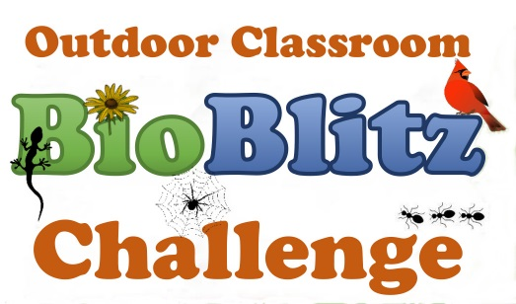
Tips &
Checklists

Before the BioBlitz Tips…
- Watch a quick video at http://www.nationalgeographic.org/media/schoolyard-bioblitz/.
- Utilize the free BioBlitz planning materials & resources on the Alabama Wildlife Federation’s website at https://www.alabamawildlife.org/outdoor-classroom-bioblitz/.
- Contact your local Outdoor Classroom Consultant so that s/he can help you register your school in the OC BioBlitz Challenge, organize your BioBlitz, and provide technical assistance during your event.
- Keep it small. Consider starting with your class or your student club instead of trying to involve your whole school.
- Divide the campus up into the same number of zones as the number of groups that you have so that each group will be exploring a different zone.
- Provide a map of the school grounds with each Zone highlighted for the volunteers, so they can scope out the Zone that their group will be exploring before the BioBlitz starts (if possible).
- Divide students into groups BEFORE the day of the BioBlitz event. Limit groups to 5-6 students if possible. Optimum number of students per group would be 3-4 students.
- Have a schedule and share it with the volunteers before the BioBlitz event.
- Provide a lesson on the classification and taxonomy of animals, plants, fungi, etc. Note: A Taxonomy PowerPoint & Terminology Handout are available on AWF’s website.
- Review the Observation Data Sheet with the students and volunteers. Note: Example Observation sheets are available on AWF’s website.
- Provide a lesson on How to Collect Specimens so that students and volunteers will not harm animals.
- Provide a lesson on How to Take Photos with the class cameras or tablets.

Example BioBlitz Event Options…
- You will have to decide how best to hold your BioBlitz based on the amount of time you have available, the age of your students, and the number of volunteers that you have to help.
- Hold the BioBlitz during three 30-60 minute blocks with a schedule such as…
  - Block #1 – Review classification and taxonomy and how to collect specimens
  - Block #2 – Go outside, record observations, and collect specimens
  - Block #3 – Go inside, identify specimens, and report observations on iNaturalist
Alabama Outdoor Classroom BioBlitz Tips & Checklists…

- Hold the BioBlitz during 30-60 minute blocks throughout a week with a schedule such as…
  - Day #1 – Review classification and taxonomy
  - Day #2 – Review how to collect specimens and how to record observations
  - Day #3 – Review how to take photos and upload data to iNaturalist
  - Day #4 – Hold BioBlitz, collect specimens, and record data on observation sheets
  - Day #5 – Enter observations into iNaturalist

- Hold the BioBlitz in one day with a schedule such as…
  - 8:30 am – Use Taxonomy PowerPoint to review classification and taxonomy
  - 9:00 am – Pass out Observation sheets and Taxonomy Tips, and then review them
  - 9:30 am – Review how to collect specimens
  - 10:00 am – Review how to take photos with cameras or digital devices like tablets
  - 10:30 am – Groups go to each of their zones to record observations and collect specimens
  - 11:30 am – Break for lunch
  - 12:30 pm – Gather student groups to begin work on identifying specimens
  - 1:00 pm – Demonstrate how to upload data to your school’s iNaturalist account
  - 1:30 pm – Students enter data and upload photos of their specimens into iNaturalist
  - 2:00 pm – Wrap up and review all species found with the whole class

Additional Suggestions for the BioBlitz…
- Review your Outdoor Classroom rules and safety tips with your volunteers and your students.
- Assign the students to their groups of 3-6 students each.
- Assign a mentor (older student, parent, or community volunteer) to each group.
- Give each group a specific area on your campus to explore.
- Decide what types of living things you want your students to document. For example, you could require each group to find one plant, one animal & one fungi in their Zone, or you could focus only on plants or only on animals. It’s your BioBlitz…so set it up so that it meets your educational goals.
- Have the students record their observations using OC BioBlitz data sheets and cameras (or devices like an iPad that have a camera).
- Gather the students to identify the flora and fauna that they found in area where they can spread out as they work on identifying their specimens.
- Show specimens on ELMO or projector & screen so that the whole class can see them in detail.
- Provide multiple sources of field guides, if possible.
- If the students have access to the internet, write the website addresses for safe websites that students can use to help them identify their specimens. Example websites include:
  - Alabama Dept of Conservation - http://www.outdooralabama.com/watchable-wildlife
  - Cornell’s Lab of Ornithology - https://www.allaboutbirds.org/
- Bug Guide - http://bugguide.netReport your school’s observations using iNaturalist.

