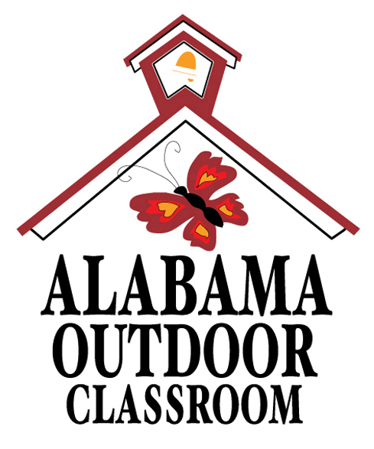 | Alabama Outdoor Classroom Program  Maintenance Plan Checklist
Use this checklist to establish a Maintenance Plan(s) for your outdoor classroom. Be as specific as possible, so that volunteers will have a clear understanding of their responsibilities.
Make copies of this Maintenance Plan Checklist as needed.
OC Learning Station(s)/Component(s): _____________________________________________________
Name of Class/Student Club/Volunteer Group:______________________________________________
Person Responsible for Project: ___________________________________________________________
Contact Person’s Email Address:______________________________ Phone #:____________________
Type of Maintenance: | - Weekly Duties | - Monthly Duties | - Summer Duties | - Work Day Project

 | - Fall Semester “Learning Station Adoption” | - Spring Semester “Learning Station Adoption”
Date(s) of Project:_______________________________________________________________________
General Description of Maintenance Project:________________________________________________
_______________________________________________________________________________________
_______________________________________________________________________________________
Maintenance Project Tasks: Be sure to include any equipment, supplies or tools needed to complete the maintenance project along with an estimated cost (if any), the estimated amount of time needed to accomplish each task, and the frequency (how often) each task should be done.
Task Description | Supplies or Tools Needed | Estimated Cost | Estimated Time Needed | Frequency of Task
Ex/ Fill the bird feeders and clean the outside of each one with a Clorox wipe. | Song Bird Food &  Clorox Wipes | $20 for bird food | 1o-15 minutes | Twice per week
Outdoor Classroom Maintenance Plan Checklist – 1713 Alabama Outdoor Classroom Planning Guide Appendix, Page 19 (1 of 2)

Alabama Outdoor Classroom Program
Maintenance Plan Checklist
Maintenance Project(s): _________________________________________________________________
Completion of Maintenance Plan: Use the following chart as a means of documenting when various tasks are completed to help you track your group’s accomplishments and to help future groups know when certain tasks were accomplished from year to year. The chart will also help you keep up with recurring tasks.
Date Completed | Task Description | Supplies/Tools Used & Cost (if any) | # of Students Involved | Amount of Time Spent on Task
List any comments or suggestions regarding the completed maintenance project: _________________
_______________________________________________________________________________________
_______________________________________________________________________________________
_______________________________________________________________________________________
_______________________________________________________________________________________
_______________________________________________________________________________________
The Alabama Outdoor Classroom Program is a partnership between:
 | 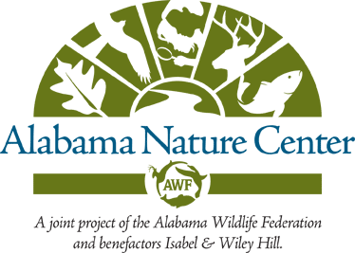    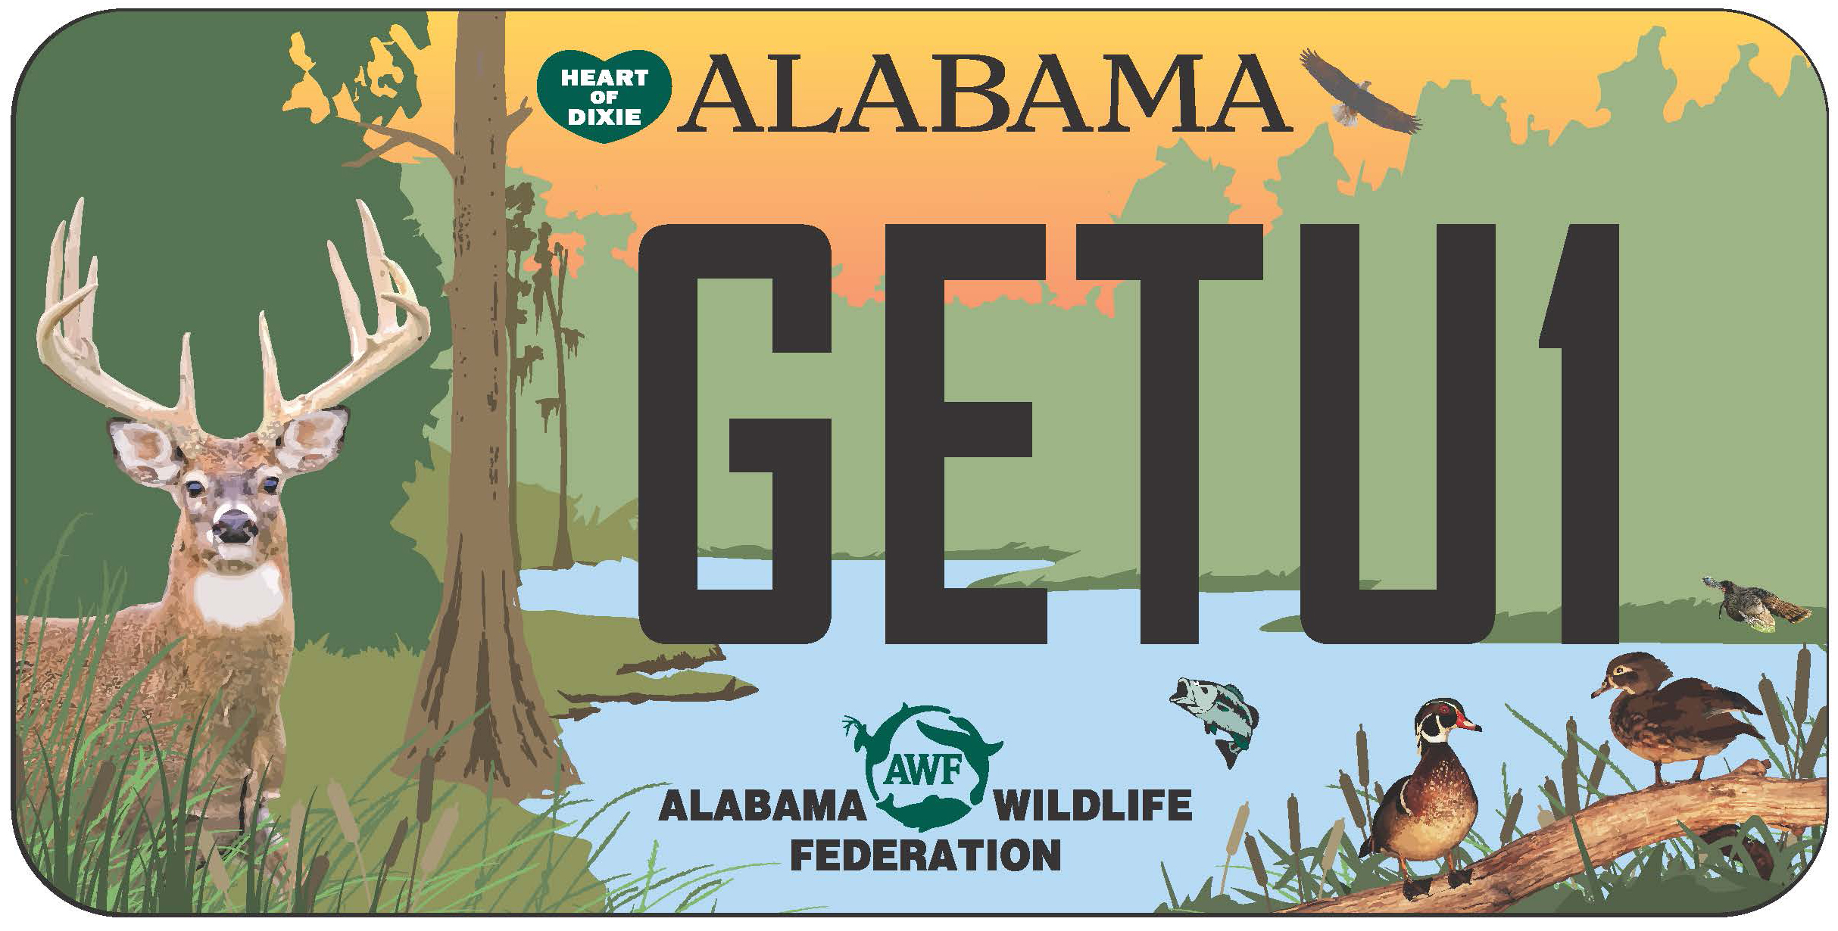 | 
Alabama Cooperative  Extension System | Alabama Wildlife Federation  www.alabamawildlife.org/classrooms/ | Alabama Department of  Conservation & Natural Resources
Outdoor Classroom Maintenance Plan Checklist – 1713 Alabama Outdoor Classroom Planning Guide Appendix, Page 19 (2 of 2)

